Quartz (Aura)
- Master healer
- Activates all chakras
- Energy ascension
- Activates body’s natural healing mechanism
Mookaite
- (Jasper) “Supreme Nurturer”
- Brings balance between inner and outer experiences
- Helps in decision making
- Physically stabilizing
- Stabilizes blood and immune system
Garnet
- Energizing and regenerating
- Cleanses and reenergizes chakras
- Revitalizes, purifies, and balances energy
- Removes inhibitions
- Regenerates body and stimulates metabolism
Amazonite
- Powerful filter
- Protects against electromagnetic pollution
- Combines intellect with intuition
- Brings emotional balance
- Fosters constructive expression of emotions
- Favorite stone of writers and musicians
Hematite
- Grounding and protecting
- Harmonizes mind, body, and spirit
- Dissolves negativity and prevents negative energies entering the aura
- Boosts self-esteem and confidence
Quartz (Rose)
- Unconditional love and infinite peace
- Heart chakra stone that purifies and opens the heart on all levels
- Attracts love
- Draw off negative energy and replaces it with loving vibes
Turquoise
- Efficient healer for solace of spirit and well-being of body
- Protective
- Spiritual attunement
- Enhances communication with physical and spiritual worlds
- Strengthens meridians
- Enhances physical and psychic immune systems
- (Tibetan Turquoise) Clears suppressed self-expression
- Chakra Point – Throat and Third Eye
Magnesite
- Deep peace to meditation and relaxation
- Enhances visualization and imagery
- Unconditional love, including self-love and love for difficult people due to behavior or addiction
- Calming effect to emotions, promoting tolerance for emotional stress
- Chakra Point – Throat and Heart
Mariposite
- Helps in adapting to new situations
- Stress reducer and stabilizes energy
Amazonite
- Powerful filter
- Protects against electromagnetic pollution
- Combines intellect with intuition
- Brings emotional balance
- Fosters constructive expression of emotions
- Favorite stone of writers and musicians
Quartz
- “Master Healer” – Can be used for any condition
- Most powerful healing and energy amplifier

Agate (Green)
- Very stable and grounding
- Brings emotional, physical, and intellectual balance
- Harmonizes yin and yang
- (Green) Improves decision making
- (Green) Good at solving disputes
Onyx
- Strength giving
- Provides support in difficult or confusing circumstances and times of enormous mental or physical stress
Labradorite
- “Light Bringer”
- Highly mystical and protective stone
- Raises consciousness and connects with universal energies
- Deflects unwanted energies and prevents energy leakage

Magnesite
- Deep peace to meditation and relaxation
- Enhances visualization and imagery
- Unconditional love, including self-love and love for difficult people due to behavior or addiction
- Calming effect to emotions, promoting tolerance for emotional stress
- Chakra Point – Throat and Heart
Sodalite
- Unites logic with intuition and opens spiritual perception
- Stimulates pineal gland
- Clears electromagnetic pollution
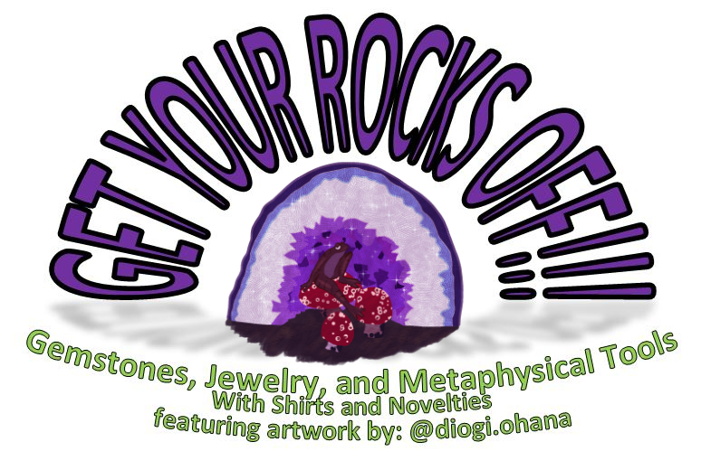
Magnesite and Sodalite Bracelet
$15

www.getyourrocksoff.shop
@getyourrocksoffshop

Agate (Green), Onyx, and
Labradorite Bracelet
$15

www.getyourrocksoff.shop
@getyourrocksoffshop

Mariposa, Amazonite, and Quartz Bracelet
$15

www.getyourrocksoff.shop
@getyourrocksoffshop

Quartz (Aura), Mookaite, and Garnet
$15 Bracelet

www.getyourrocksoff.shop
@getyourrocksoffshop
Amazonite, Hematite,
and Quartz (Rose) Bracelet
$12

www.getyourrocksoff.shop
@getyourrocksoffshop

Turquoise and Magnesite Bracelet
$15

www.getyourrocksoff.shop
@getyourrocksoffshop

Unakite
- Stone of vision
- Balances emotions with spirituality
- Opens and promotes visualization and psychic vision
Quartz (Watermelon)
- “Super Activator” – Heart Chakra
- Links higher self to the fostering of love, tenderness, and friendship
- Instils patience and teaches tact and diplomacy
- Alleviates depression and fear
- Helps treat paranoia and to find joy in any situation
Jasper (Green)
- “Supreme Nurturer”
- Releases obsession
- Chakra Point - Heart

Jasper (Green)
- “Supreme Nurturer”
- Releases obsession
- Chakra Point - Heart
Quartz (Rose)
- Unconditional love and infinite peace
- Heart chakra stone that purifies and opens the heart on all levels
- Attracts love
- Draw off negative energy and replaces it with loving vibes

Bloodstone
- Heightens intuition and increases creativity
- Excellent for grounding and protection
- Staves off undesirable influences
- Calms the mind and dispels confusion
- Reduces irritability, aggressiveness, and impatience
Garnet
- Energizing and regenerating
- Cleanses and reenergizes chakras
- Revitalizes, purifies, and balances energy
- Removes inhibitions
- Regenerates body and stimulates metabolism
Labradorite
- “Light Bringer”
- Highly mystical and protective stone
- Raises consciousness and connects with universal energies
- Deflects unwanted energies and prevents energy leakage
Quartz
- “Master Healer” – Can be used for any condition
- Most powerful healing and energy amplifier
- Raises energy to highest possible level

Bloodstone
- Blood cleanser and natural healer
- Heightens intuition and increases creativity
- Excellent for grounding and protection
- Staves off undesirable influences
- Calms the mind and dispels confusion
- Reduces irritability, aggressiveness, and impatience
- Immune simulator
Garnet
- Energizing and regenerating
- Cleanses and reenergizes chakras
- Revitalizes, purifies, and balances energy
- Removes inhibitions
- Regenerates body and stimulates metabolism
Quartz (Watermelon)
- “Super Activator” – Heart Chakra
- Links higher self to the fostering of love, tenderness, and friendship
- Instils patience and teaches tact and diplomacy
- Alleviates depression and fear
- Helps treat paranoia and to find joy in any situation

Onyx
- Strength giving
- Provides support in difficult or confusing circumstances and times of enormous mental or physical stress
Malachite
- *Do NOT ingest or soak in liquid – cleanse with quartz after each use*
- Chakra Point – Throat
- Amplifies positive and negative energy
- Grounds spiritual energy onto the planet
- Absorbs negative energy and pollution
- Transformation stone
- Deep emotional healing
Hematite
- Grounding and protecting
- Harmonizes mind, body, and spirit
- Dissolves negativity and prevents negative energies entering the aura
- Boosts self-esteem and confidence
Tiger’s Eye
- Well-grounded and a high-vibrational state; draws spiritual energies to earth
- Protective against ill wishing and curses
- Treats eyes and aids night vision

Tiger’s Eye
- Well-grounded and a high-vibrational state; draws spiritual energies to earth
- Protective against ill wishing and curses
- Treats eyes and aids night vision
Labradorite
- “Light Bringer”
- Highly mystical and protective stone
- Raises consciousness and connects with universal energies
- Deflects unwanted energies and prevents energy leakage
Onyx
- Strength giving
- Provides support in difficult or confusing circumstances and times of enormous mental or physical stress

Bloodstone, Garnet, Labradorite, and
Quartz Bracelet
$15

www.getyourrocksoff.shop
@getyourrocksoffshop
Jasper (Green)
and Quartz (Rose) Bracelet
$15

www.getyourrocksoff.shop
@getyourrocksoffshop
Unakite, Quartz (Watermelon), and
Jasper (Green) Bracelet
$15 Bracelet

www.getyourrocksoff.shop
@getyourrocksoffshop

Tiger’s Eye, Labradorite,
and Onyx Bracelet
$15

www.getyourrocksoff.shop
@getyourrocksoffshop
Onyx, Malachite, Hematite, and Tiger’s Eye Earring and Bracelet Set
$25

www.getyourrocksoff.shop
@getyourrocksoffshop
Bloodstone, Garnet, and Quartz (Watermelon) Necklace
$18

www.getyourrocksoff.shop
@getyourrocksoffshop

